**EXPERIMENT 8**

Write the python to implement Travelling Salesman Problem.

**AIM:**

The aim is implement travelling salesman problem using python program.

**PROGRAM:**

from itertools import permutations

def tsp_brute_force(graph):

cities = list(range(1, len(graph)))

permutations_cities = permutations(cities)

min_path = None

min_distance = float('inf')

for perm in permutations_cities:

distance = 0

last_city = 0

for city in perm:

distance += graph[last_city][city]

last_city = city

distance += graph[last_city][0]

if distance < min_distance:

min_distance = distance

min_path = (0,) + perm

return min_path, min_distance

dist = [[0, 10, 15, 20], [10, 0, 35, 25], [15, 35, 0, 30], [20, 25, 30, 0]]

path, distance = tsp_brute_force(dist)

print(f"The shortest path is {path} with total distance {distance}")

**INPUT:**

cities = ['A', 'B', 'C', 'D']

**OUTPUT:**

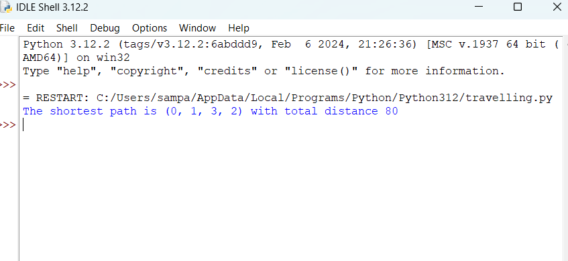

**RESULT:**

This program executed successfully.